Forensic Container Approach
  - Alerts to Answers Analyst Field Guide 09 · v23
The opening foundation follows the original container slides 2–4 with factual corrections: timestamp changes, the container preservation boundary and the four-stage transfer workflow. An analyst must explain what a transfer preserved, what the destination created, and how the result was checked. This guide follows the recorded Linux (Ubuntu) and Windows procedures in their own execution order, then applies those findings to a separate portable container exercise.
The command IDs below match the revised slides. Linux (Ubuntu) 01–13 are the original Linux script tests. Windows 00–10 are the longer controlled workbook procedure, followed by Windows analysis 1–7. C01–C16 identify the separate container application. Slide page numbers are navigation only.
Use a disposable VM and synthetic files. The recorded commands are excerpts of the full procedures; logging helpers and setup remain in the supplied source scripts. Preserve original screenshots, logs, CSVs and independently held integrity receipts.

Script locations
In the Student Kit: Scripts/Linux_Forensic_Time_Validator.sh and Scripts/Windows_Forensic_Claims_Validation.ps1. Procedures/Controlled_NTFS_Operations_with_Zimmerman_Setup_v8.md contains the separate Windows 00–10 procedure. In the project, these kit resources are under Student. Original source scripts and the harness ZIP remain preserved in their original project locations.

Reading the evidence
Linux (Ubuntu) screenshots here are run 20260920T144257Z. They are separate from the September 19 raw-log run and September 20 WSL container qualification. The Windows workbook screenshots show the controlled September 19 run. New times, identities and digests will differ in a new run.
Learning objective: Show the command, explain why it was chosen, identify its OS/time effect, inspect the actual result, document the limits, and state a bounded analyst conclusion.
The v23 deck has 44 slides. Linux begins on slide 5 and Windows on slide 22. C01–C16 are a separate application tutorial, not additional deck slides. The instructor retains the deck with answer notes and the 37-page screenshot walkthrough. PacketParsing companion PCAPNGs were not the inputs to the timestamp experiments.

Common causes of file timestamp changes
Deck slide 2 · Original step Foundation 1

Command syntax
Content writes: editor saves, application writes, redirection, logs
Reads: hashing and copying can affect access time
Metadata operations: chmod, ACLs, touch, rename
Linux fields: mtime, atime, ctime and supported birth time
Why this syntax: Before transferring evidence, predict which operation can change which field. Then test that prediction on the actual OS and filesystem.
OS and time effect: mtime records content modification but can also be set. atime depends on access policy. ctime records inode status change. Birth time records object creation when supported.
Gotcha or ProTip: Same-filesystem mv normally retains the inode, but ctime can change. Linux ctime is not creation time; ordinary timestamp-setting APIs do not restore it.
Connection to the container lesson: The container workflow defines the claim.
Recorded result or expected outcome: Ubuntu 02–10 and Windows 02–09 show why content identity, timestamps and object identity require separate checks.
Analyst takeaway: Know what the tool changes before you interpret the resulting timeline.

Forensic Container Approach
Deck slide 3 · Original step Foundation 2

Command syntax
Layer 1: source bytes and recorded metadata
Layer 2: archive members and stored metadata
Layer 3: received archive and extracted objects
Scope: logical file container, not a filesystem image
Why this syntax: The v5 Kali-to-Windows scenario needs a portable package that keeps selected source records interpretable across operating systems.
OS and time effect: An unchanged archive can carry source bytes and metadata records through Windows. Extraction creates destination objects with filesystem-dependent metadata.
Gotcha or ProTip: scp -p requests source modification/access times and mode bits on the transferred archive. It does not clone source inode identity, ctime, birth time, ACLs or journal history.
Connection to the container lesson: The container workflow defines the claim.
Recorded result or expected outcome: We validate local file/container behavior below. Actual SSH endpoints and email transport were not validated by the supplied screenshot run.
Analyst takeaway: Verify container bytes separately from destination timestamps.

Forensic Transfer Guide
Deck slide 4 · Original step Foundation 3

Command syntax
1 Record source state before content reads
stat evidence.log; sha256sum evidence.log
2 Package selected members and metadata records
tar --format=pax --acls --xattrs ...
3 Hash the completed archive; retain trusted receipt
sha256sum evidence.tar.gz; scp -p ...
4 Verify archive BEFORE extraction, then compare
sha256sum -c; tar -xzf ...; stat evidence.log
Why this syntax: This is the four-stage workflow from v5 slide 4. The later C01–C16 tutorial supplies complete runnable syntax and a defined synthetic workspace.
OS and time effect: GNU tar --atime-preserve=system aims to avoid changing source access time while archiving. It is not a promise to restore the extracted file’s original atime.
Gotcha or ProTip: Use SHA-256 for this lab. MD5 is not required. Compare the archive to an independently held digest before extraction; a checksum delivered beside it is not independently trusted.
Connection to the container lesson: The container workflow defines the claim.
Recorded result or expected outcome: Expected: archive/content hashes match the chosen baseline. Measure metadata individually. New inode, ctime or birth time can be expected; record rather than conceal differences.
Analyst takeaway: Verify each transition and make a preservation claim only for the properties actually checked.

Why we created the Linux script
Deck slide 5 · Original step Linux overview 1

Command syntax
stat # inode and four time fields
sha256sum # content identity
cp / mv # copy and rename
chmod / touch / setfacl / setfattr
tar # package and extract
Why this syntax: The validator measures how familiar Linux operations affect content, file identity and metadata on a recorded filesystem.
OS and time effect: Controlled 2024 timestamps distinguish inherited values from times generated by the 2026 operation.
Gotcha or ProTip: Read effects depend on mount policy. The saved screenshots are one ext4/relatime run, not every Linux system.
Connection to the container lesson: Slide 2: operations can change metadata without changing content.
Recorded result or expected outcome: Tests 01–10 establish behavior. Test 11 packages the source. Test 12 checks extraction. Test 13 is optional SCP.
Analyst takeaway: Use controlled observations to choose and qualify a preservation method.

How to use and read the Linux script
Deck slide 6 · Original step Linux overview 2

Command syntax
bash ./Linux_Forensic_Time_Validator.sh
# ENTER = execute next test
# s = skip; q = quit
# work/ = synthetic files
# logs/ = state, hashes and transcript
# results/ = claims and final summary
Why this syntax: Run the complete supplied script in a disposable Ubuntu lab. It creates a dated workspace and records the sequence.
OS and time effect: state() prints Path, Inode, Size, Mode, UID/GID, Access, Modify, Change and Birth. Hash reads can themselves affect atime.
Gotcha or ProTip: Do not skip baseline 01: later tests require F and BASE. A printed OBSERVED claim still needs the underlying logs.
Connection to the container lesson: Slide 2: operations can change metadata without changing content.
Recorded result or expected outcome: The following slides use the script’s original test IDs. Visible snippets are core commands; the full harness handles pauses and logs.
Analyst takeaway: Preserve the run folder and raw records alongside the screenshots.

Linux pre-flight and environment
Deck slide 7 · Original step Linux pre-flight

Command syntax
cat /etc/os-release
uname -a
findmnt -T "$W" \
-o TARGET,SOURCE,FSTYPE,OPTIONS
# W is the harness work directory
Why this syntax: Identify the environment before testing timestamp behavior. findmnt links the workspace to its actual filesystem and mount policy.
OS and time effect: relatime permits conditional access-time updates; it does not promise a new atime for each read.
Gotcha or ProTip: The capture also includes test 01 below pre-flight. Its displayed local offset changes between winter and summer.
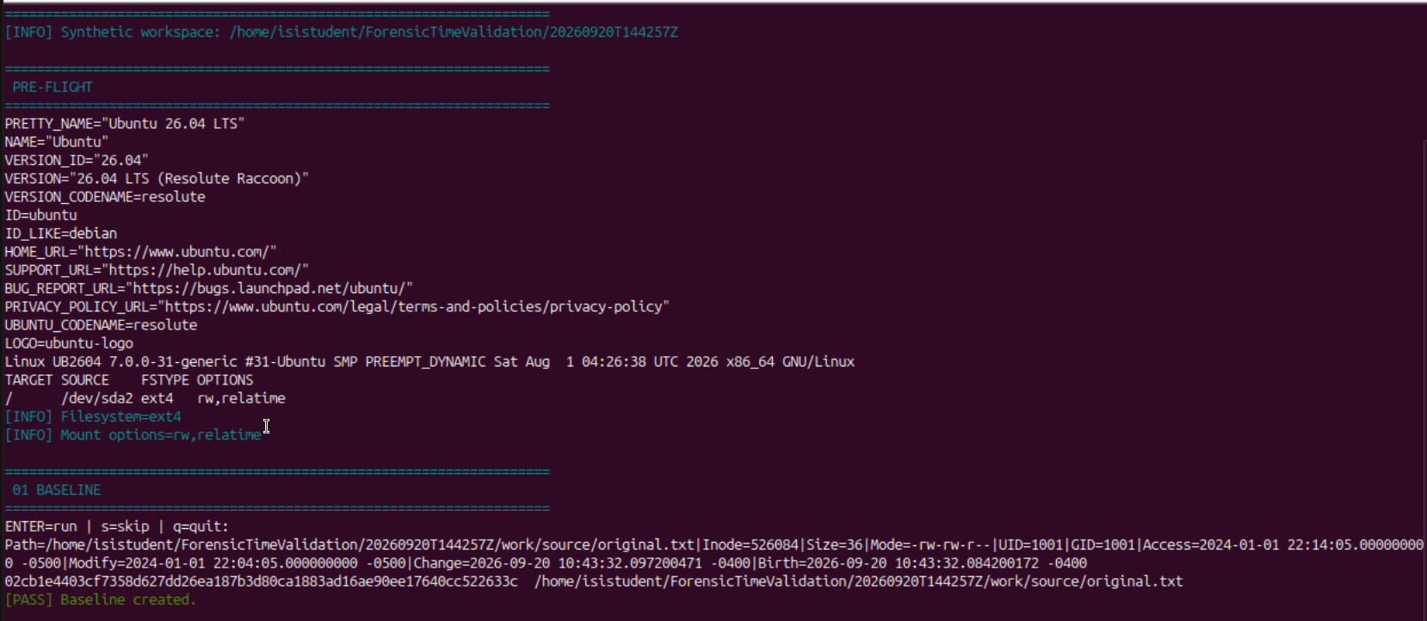
Figure Linux pre-flight. PRE-FLIGHT and 01 share the same original capture
Connection to the container lesson: Slide 2: operations can change metadata without changing content.
Recorded result or expected outcome: Recorded: Ubuntu 26.04 LTS; kernel 7.0.0-31-generic; ext4 mounted rw,relatime.
Analyst takeaway: Tie timestamp findings to the recorded OS, filesystem and time policy.

Linux 01 Baseline
Deck slide 8 · Original step Linux 01

Command syntax
F="$W/source/original.txt"
printf "FORENSIC LINUX TIMESTAMP VALIDATION\n" > "$F"
touch -m -d "2024-01-02 03:04:05 UTC" "$F"
touch -a -d "2024-01-02 03:14:05 UTC" "$F"
state "$F"
sha256sum "$F"
BASE="$(hash "$F")"
Why this syntax: Create known content and deliberately set mtime and atime. state() records the controlled file before the baseline hash reads.
OS and time effect: touch sets selected timestamps. ctime and birth time still describe the new filesystem object.
Gotcha or ProTip: The baseline hashes the source twice. Test 02 is therefore a later read, not the first read of untouched data.
Figure Linux 01. 01 BASELINE, lower part of the pre-flight capture
Connection to the container lesson: Slide 2: operations can change metadata without changing content.
Recorded result or expected outcome: 01 BASELINE: 36 bytes; inode 526084; mtime 2024-01-01 22:04:05 -0500; atime 22:14:05 -0500. Hash begins 02cb1e44.
Analyst takeaway: A baseline records both deliberate settings and the effects of the measurement process.

Linux 02 SHA256SUM read effect
Deck slide 9 · Original step Linux 02

Command syntax
state "$F"
A1="$(stat -c %x "$F")"
sleep 5
sha256sum "$F"
state "$F"
A2="$(stat -c %x "$F")"
Why this syntax: Read the same source bytes and compare access time before and after this measured interval.
OS and time effect: SHA-256 reads content. The filesystem decides whether and when that read updates atime.
Gotcha or ProTip: A1 and A2 match here after prior baseline reads. That cannot establish that hashing never changes atime.
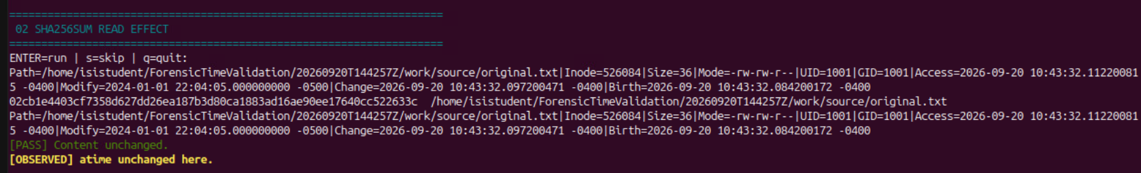
Figure Linux 02. Original test 02, screenshot run 20260920T144257Z
Connection to the container lesson: Slide 2: operations can change metadata without changing content.
Recorded result or expected outcome: 02 SHA256SUM READ EFFECT: content unchanged; displayed atime unchanged at 2026-09-20 10:43:32.112200815 -0400.
Analyst takeaway: Interpret a read in its sequence and mount policy, not from one unchanged value.

Linux 03 Default cp
Deck slide 10 · Original step Linux 03

Command syntax
D="$W/copy_default/original.txt"
sleep 5
cp "$F" "$D"
state "$F"
state "$D"
sha256sum "$F" "$D"
Why this syntax: F is the original harness fixture; W is its work directory. state() is the script’s stat wrapper. The harness created each destination directory first.
OS and time effect: A new destination gets a new inode and newly assigned times in this run.
Gotcha or ProTip: The copy can match byte-for-byte while timestamps describe a new object.
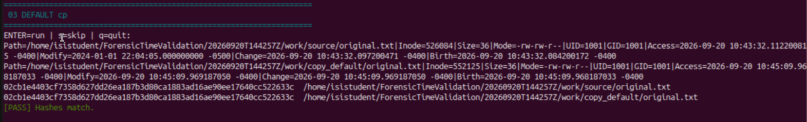
Figure Linux 03. Original test 03, screenshot run 20260920T144257Z
Connection to the container lesson: Slides 2–3: matching bytes do not establish unchanged filesystem identity or every timestamp.
Recorded result or expected outcome: 03 DEFAULT cp: source inode 526084; destination 552125. Hashes match. Destination mtime is a new 2026 value.
Analyst takeaway: Check content and the specific metadata fields required for your collection.

Linux 04 cp -p
Deck slide 11 · Original step Linux 04

Command syntax
D="$W/copy_p/original.txt"
sleep 5
cp -p "$F" "$D"
state "$F"
state "$D"
sha256sum "$F" "$D"
Why this syntax: F is the original harness fixture; W is its work directory. state() is the script’s stat wrapper. The harness created each destination directory first.
OS and time effect: -p requests mode, ownership and timestamp preservation, subject to permissions.
Gotcha or ProTip: -p preserves selected properties, not the original inode or its history.
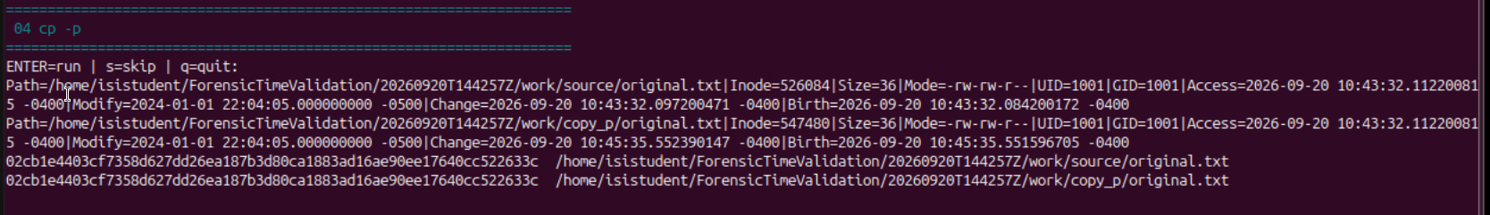
Figure Linux 04. Original test 04, screenshot run 20260920T144257Z
Connection to the container lesson: Slides 2–3: matching bytes do not establish unchanged filesystem identity or every timestamp.
Recorded result or expected outcome: 04 cp -p: destination inode 547480. mtime remains the controlled 2024 value; destination ctime/birth are new 2026 values.
Analyst takeaway: Check content and the specific metadata fields required for your collection.

Linux 05 cp -a
Deck slide 12 · Original step Linux 05

Command syntax
D="$W/copy_a/original.txt"
sleep 5
cp -a "$F" "$D"
state "$F"
state "$D"
sha256sum "$F" "$D"
Why this syntax: F is the original harness fixture; W is its work directory. state() is the script’s stat wrapper. The harness created each destination directory first.
OS and time effect: Archive copying preserves selected properties while creating a new destination object.
Gotcha or ProTip: Archive-style copying is logical preservation, not a filesystem clone.
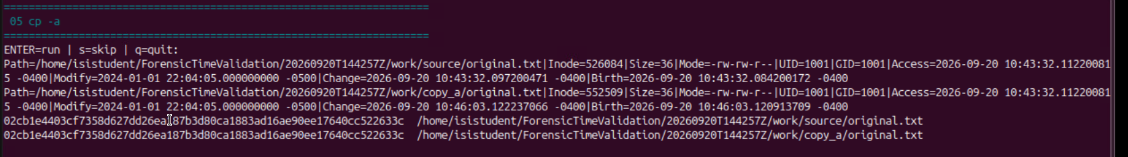
Figure Linux 05. Original test 05, screenshot run 20260920T144257Z
Connection to the container lesson: Slides 2–3: matching bytes do not establish unchanged filesystem identity or every timestamp.
Recorded result or expected outcome: 05 cp -a: destination inode 552509. Content and mtime match; inode, ctime and birth identify a new object.
Analyst takeaway: Check content and the specific metadata fields required for your collection.

Linux 06 rsync -a
Deck slide 13 · Original step Linux 06

Command syntax
D="$W/rsync_a/original.txt"
sleep 5
rsync -a "$F" "$D"
state "$F"
state "$D"
sha256sum "$F" "$D"
Why this syntax: F is the original harness fixture; W is its work directory. state() is the script’s stat wrapper. The harness created each destination directory first.
OS and time effect: Archive mode requests selected properties; it does not include ACLs, xattrs or hard links by itself.
Gotcha or ProTip: Archive mode alone does not request every metadata class. Do not infer full ACL/xattr restoration.
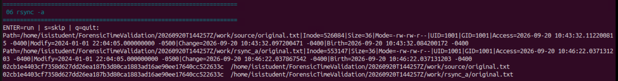
Figure Linux 06. Original test 06, screenshot run 20260920T144257Z
Connection to the container lesson: Slides 2–3: matching bytes do not establish unchanged filesystem identity or every timestamp.
Recorded result or expected outcome: 06 rsync -a: destination inode 553147. Content and mtime match; destination access, change and birth times are 2026 values.
Analyst takeaway: Check content and the specific metadata fields required for your collection.

Linux 07 Same-filesystem mv
Deck slide 14 · Original step Linux 07

Command syntax
B="$W/rename/before.txt"
A="$W/rename/after.txt"
cp -p "$F" "$B"
state "$B"
sleep 5
mv "$B" "$A"
state "$A"
Why this syntax: The test prepares a file, records its state, renames it on the same filesystem, then records state again.
OS and time effect: The rename updates filesystem metadata while retaining the observed inode.
Gotcha or ProTip: The screenshot also shows an atime difference in the broader sequence. Do not attribute every changed field to the rename alone.
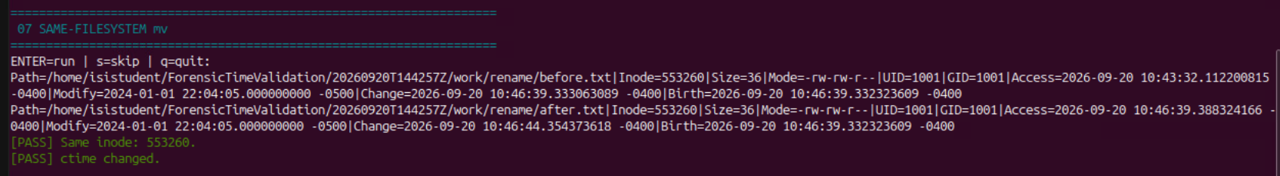
Figure Linux 07. Original test 07, screenshot run 20260920T144257Z
Connection to the container lesson: Slides 2–3: matching bytes do not establish unchanged filesystem identity or every timestamp.
Recorded result or expected outcome: Inode remains 553260
mtime and birth time remain equal
ctime changes
Analyst takeaway: A rename can retain file identity while changing metadata.

Linux 08 chmod metadata change
Deck slide 15 · Original step Linux 08

Command syntax
D="$W/metadata_change.txt"
cp -p "$F" "$D"
state "$D"
sha256sum "$D"
sleep 5
chmod 600 "$D"
state "$D"
sha256sum "$D"
Why this syntax: 600 gives the owner read/write access and removes group/other access. Compare content digest, Modify and Change fields.
OS and time effect: chmod 600 changes permission bits and ctime without changing the content or mtime here.
Gotcha or ProTip: This teaching excerpt shows the same measured fields. The full harness stores before/after values and tests them; its hashing order includes extra reads.
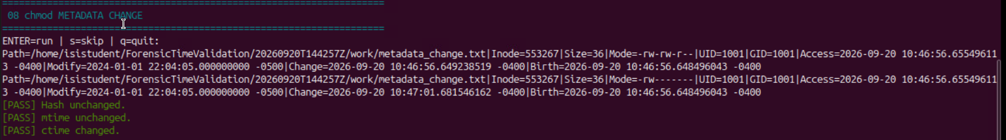
Figure Linux 08. Original test 08, screenshot run 20260920T144257Z
Connection to the container lesson: Slide 2: operations can change metadata without changing content.
Recorded result or expected outcome: Hash unchanged
mtime unchanged
ctime changed
Analyst takeaway: Content integrity and metadata activity require separate findings.

Linux 09 touch backdating
Deck slide 16 · Original step Linux 09

Command syntax
D="$W/touch_test.txt"
cp -p "$F" "$D"
state "$D"
sleep 5
touch -d '2020-01-01 12:00:00 UTC' "$D"
state "$D"
Why this syntax: The synthetic exercise deliberately assigns earlier access and modification times. Compare them to ctime and birth time.
OS and time effect: touch assigns atime and mtime; ctime reflects the later metadata change.
Gotcha or ProTip: A divergence is an investigative clue, not proof of malicious intent. Do not assign timestamps to original evidence to make results match.
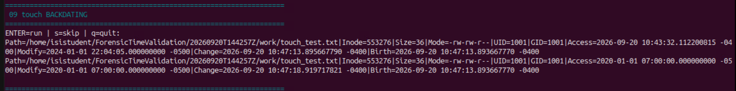
Figure Linux 09. Original test 09, screenshot run 20260920T144257Z
Connection to the container lesson: Slide 2: operations can change metadata without changing content.
Recorded result or expected outcome: Access/Modify: 2020-01-01 07:00:00 -0500
Change: 2026 test time
Birth remains unchanged.
Analyst takeaway: Timestamp values require operational context before they support a chronology.

Linux 10 ACL and xattr change
Deck slide 17 · Original step Linux 10

Command syntax
D="$W/source/metadata.txt"
cp -p "$F" "$D"
state "$D"
setfacl -m "u:$(id -un):rw" "$D"
setfattr -n user.forensic_test -v LAB409 "$D"
state "$D"
getfacl -p "$D"
getfattr -d -m- "$D"
sha256sum "$D"
Why this syntax: setfacl adds a named-user ACL entry. setfattr sets a user-namespace attribute. getfacl/getfattr expose what changed.
OS and time effect: A named ACL and a user extended attribute change metadata while content remains equal.
Gotcha or ProTip: The content digest excludes these metadata listings. A successful metadata-change test does not qualify metadata restoration after transfer.
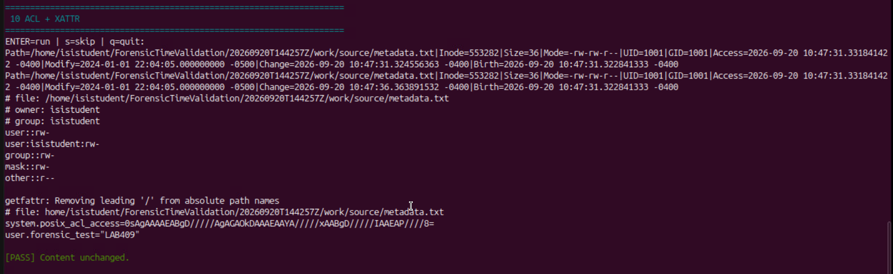
Figure Linux 10. Original test 10, screenshot run 20260920T144257Z
Connection to the container lesson: Slide 2: operations can change metadata without changing content.
Recorded result or expected outcome: user:isistudent:rw-
user.forensic_test="LAB409"
Content unchanged; ctime changed
Analyst takeaway: Capture and compare ACLs/xattrs explicitly when they matter to the evidence question.

Linux 11 TAR container
Deck slide 18 · Original step Linux 11

Command syntax
cd "$W"
ARGS=(--numeric-owner --atime-preserve=system)
tar --help | grep -q -- --acls && \
ARGS+=(--acls)
tar --help | grep -q -- --xattrs && \
ARGS+=(--xattrs)
tar "${ARGS[@]}" -czf evidence_package.tar.gz \
source ../logs/11_evidence_hashes.txt
sha256sum "$W/evidence_package.tar.gz"
Why this syntax: Exact core operations from the original script. W was that run’s work directory; its preceding step created the hash list in L.
OS and time effect: TAR serializes content and supported metadata. Its source reads may affect atime unless the requested protection works.
Gotcha or ProTip: The original used ../logs and absolute paths in the hash list. The main exercise fixes portability with explicit relative members and hashes.
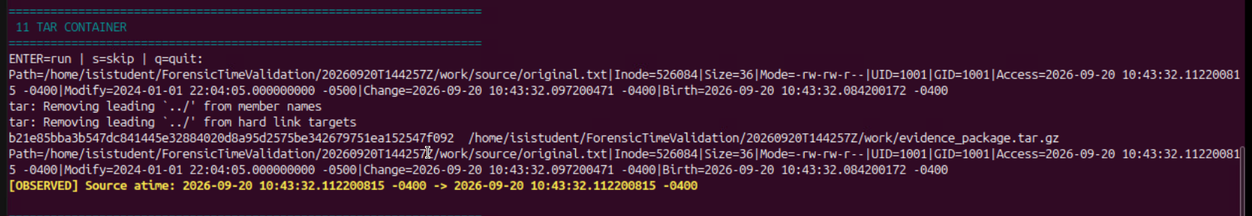
Figure Linux 11. Original test 11, screenshot run 20260920T144257Z
Connection to the container lesson: Slides 3–4: a container preserves selected contents and records; each transfer and extraction needs separate checks.
Recorded result or expected outcome: 11 TAR CONTAINER: source atime stayed equal. The archive digest begins b21e85bb. TAR warned about stripping leading ../ from member names.
Analyst takeaway: Retain warnings and explain command changes instead of hiding them.

Linux 12 TAR extraction
Deck slide 19 · Original step Linux 12

Command syntax
cd "$W"
X=()
tar --help | grep -q -- --acls && X+=(--acls)
tar --help | grep -q -- --xattrs && X+=(--xattrs)
tar "${X[@]}" -xzf evidence_package.tar.gz \
-C tar_extract
E="$W/tar_extract/source/original.txt"
state "$F"; state "$E"
sha256sum "$F" "$E"
Why this syntax: Extract the recorded archive and compare source and destination state and hashes. The options request supported metadata restoration.
OS and time effect: Extraction creates new destination objects. Matching content and mtime can coexist with new inode, ctime and birth.
Gotcha or ProTip: The original harness reuses X for TAR options and a color reset, producing stray --acls text. This is a display bug, not another test.
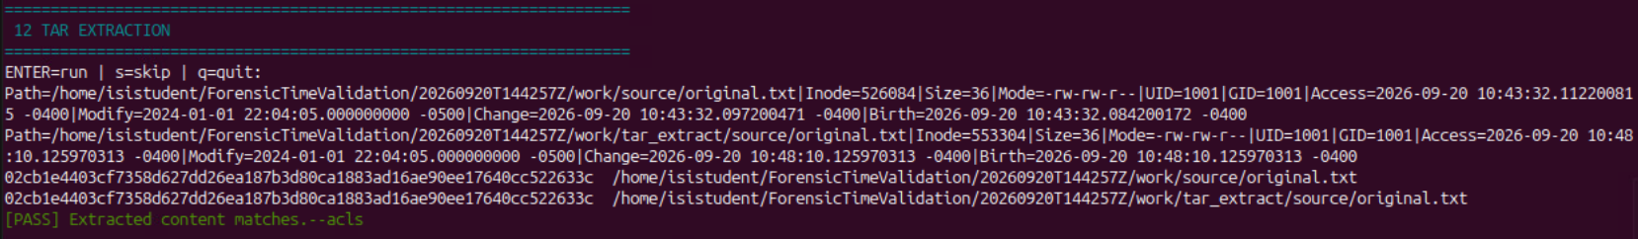
Figure Linux 12. Original test 12; this excerpt uses the original X variable
Connection to the container lesson: Slides 3–4: a container preserves selected contents and records; each transfer and extraction needs separate checks.
Recorded result or expected outcome: 12 TAR EXTRACTION: inode 526084 becomes 553304. Hashes and mtime match. Destination ctime/birth: 2026-09-20 10:48:10.125970313 -0400.
Analyst takeaway: Preserve the archive and explain the new object created by extraction.

Linux 13 Optional SCP
Deck slide 20 · Original step Linux 13

Command syntax
scp "$F" "$REMOTE:/tmp/scp_default.txt"
scp -p "$F" "$REMOTE:/tmp/scp_p.txt"
ssh "$REMOTE" \
"stat /tmp/scp_default.txt; \
stat /tmp/scp_p.txt; \
sha256sum /tmp/scp_default.txt /tmp/scp_p.txt"
Why this syntax: Compare raw-file transfer with and without -p after supplying a real, verified SSH endpoint.
OS and time effect: -p requests modification/access times and mode bits. The destination remains a separate filesystem object.
Gotcha or ProTip: This original optional step sends raw files. The later practical exercise transfers an intact TAR container instead.
Connection to the container lesson: Slides 3–4: a container preserves selected contents and records; each transfer and extraction needs separate checks.
Recorded result or expected outcome: No supplied screenshot or raw endpoint result proves this optional step ran. Keep it explicitly unvalidated.
Analyst takeaway: A planned transfer command is not evidence of a completed, verified transfer.

Linux final summary and retained results
Deck slide 21 · Original step Linux summary

Command syntax
cat "$O/Linux_Forensic_Time_Final_Summary.txt"
cat "$O/claims.tsv"
sha256sum \
"$ROOT/Linux_Forensic_Time_Validation_Results_${RUN}.tar.gz"
Why this syntax: The script collects final states, claims and a results archive so another analyst can inspect the measured operations.
OS and time effect: Final state may reflect intervening hash reads. Use each test’s before/after record to isolate its measured interval.
Gotcha or ProTip: The results bundle is different from work/evidence_package.tar.gz. Do not substitute one archive digest for the other.
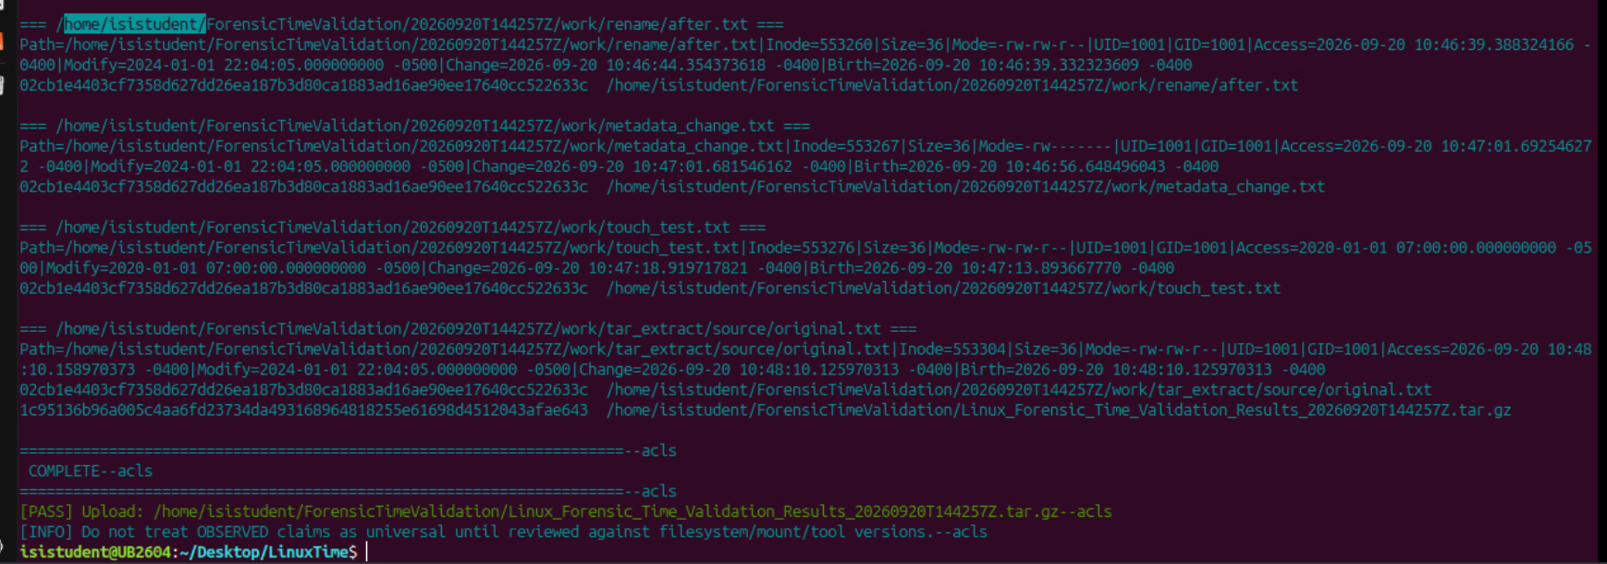
Figure Linux summary. FINAL SUMMARY and COMPLETE, after optional test 13
Connection to the container lesson: Slide 2: operations can change metadata without changing content.
Recorded result or expected outcome: Run 20260920T144257Z completed; the final summary shows the source, comparison copies and extracted object.
Analyst takeaway: Retain operation-level logs as well as the final summary.

Why we created the Windows procedures
Deck slide 22 · Original step Windows overview 1

Command syntax
Get-Item / Get-FileHash # state and content
Copy-Item / Robocopy # copy behavior
Rename-Item / Add-Content / attrib
Remove-Item # controlled deletion
MFTECmd # MFT and USN interpretation
Why this syntax: Known operations let students compare Windows API timestamps with NTFS SI/FN timestamps and journal activity.
OS and time effect: Copying may preserve selected values while NTFS creates new records. Rename, metadata change and content change leave different evidence.
Gotcha or ProTip: FileInfo alone does not expose both SI and FN timestamp sets. A matching hash does not certify NTFS metadata preservation.
Connection to the container lesson: Slide 2: operations can change metadata without changing content.
Recorded result or expected outcome: The screenshots follow the controlled procedure: environment 0, operations 1–10, then MFT/USN analysis.
Analyst takeaway: Correlate the known action, content hash, MFT state and journal activity.

How the Windows sources fit together
Deck slide 23 · Original step Windows overview 2

Command syntax
pwsh -File .\Windows_Forensic_Claims_Validation.ps1
# Separate automated harness: tests 01–06
# Workbook run: controlled operations 0–10
# After operation 10: preserve filesystem
# Then parse MFT and USN for comparison
Why this syntax: Use a disposable Windows/NTFS VM. The automated harness creates a dated workspace, transcript and claims matrix. The workbook follows the longer manual procedure.
OS and time effect: Harness 01–06 correspond to controlled operations 2–7. Controlled operations 8–10 add content change, attribute change and deletion.
Gotcha or ProTip: Never renumber the manual screenshots as harness tests. The supplied harness is a separate six-test implementation.
Connection to the container lesson: Slide 2: operations can change metadata without changing content.
Recorded result or expected outcome: The next slides retain the workbook’s operation IDs. Syntax excerpts are taken from that controlled procedure.
Analyst takeaway: Name the procedure and test ID before comparing results.

Windows 00 Environment
Deck slide 24 · Original step Windows 00

Command syntax
New-Item -ItemType Directory C:\ForensicTest -Force
Set-Location C:\ForensicTest
Get-Date -Format o
w32tm /query /status
fsutil behavior query disablelastaccess
Get-Volume C
Why this syntax: Record time service, filesystem and last-access policy before the experiment.
OS and time effect: Policy and synchronization affect timestamp interpretation.
Gotcha or ProTip: The time-service query failed in the captured VM. Do not describe its clock as verified synchronized.
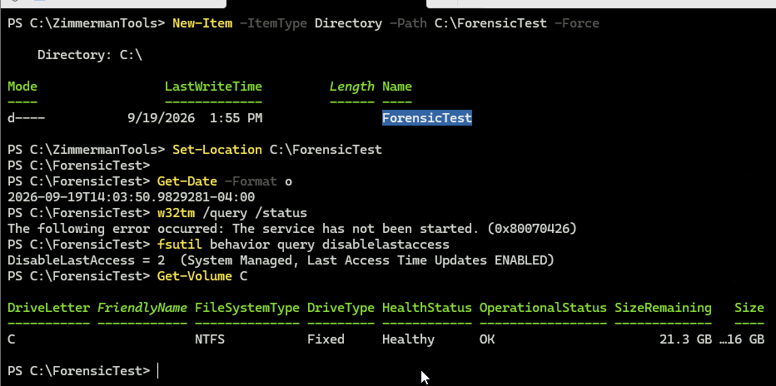
Figure Windows 00. Controlled procedure operation 0; workbook screenshot from September 19
Connection to the container lesson: Slide 2: operations can change metadata without changing content.
Recorded result or expected outcome: NTFS is shown; DisableLastAccess=2, system managed with updates enabled. w32tm reports service not started.
Analyst takeaway: Record clock uncertainty alongside the timestamp values.

Windows 01 Baseline
Deck slide 25 · Original step Windows 01

Command syntax
"FORENSIC TIMESTAMP VALIDATION" | Set-Content .\Original.txt
$F = 'C:\ForensicTest\Original.txt'
[IO.File]::SetCreationTimeUtc($F, '2024-01-02T02:54:05Z')
[IO.File]::SetLastWriteTimeUtc($F, '2024-01-02T03:04:05Z')
[IO.File]::SetLastAccessTimeUtc($F, '2024-01-02T03:14:05Z')
Get-Item $F | Format-List *TimeUtc,Length,Attributes
Get-FileHash $F -Algorithm SHA256
Why this syntax: Create known bytes and deliberately set three API-visible UTC values.
OS and time effect: The APIs set selected timestamps; later MFT analysis distinguishes SI from FN.
Gotcha or ProTip: The display command is shortened here. The original screenshot uses Select-Object. Hashing is already a read.
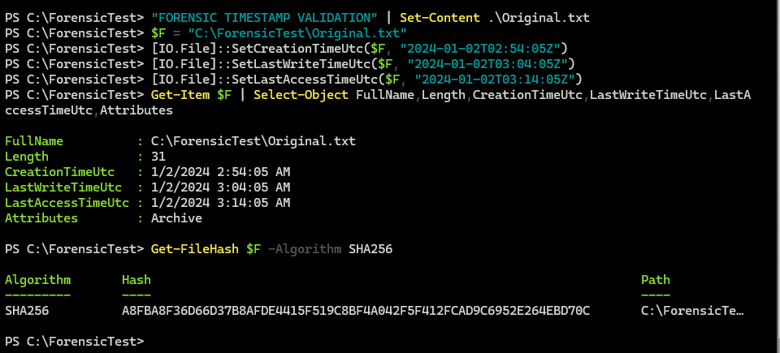
Figure Windows 01. Controlled procedure operation 1; workbook screenshot from September 19
Connection to the container lesson: Slide 2: operations can change metadata without changing content.
Recorded result or expected outcome: Original.txt is 31 bytes. Creation 02:54:05, write 03:04:05 and access 03:14:05 UTC on 2024-01-02.
Analyst takeaway: An intentionally set timestamp must be interpreted with the known operation.

Windows 02 Hash and read
Deck slide 26 · Original step Windows 02

Command syntax
Start-Sleep 5
Get-FileHash $F -Algorithm SHA256
Get-Item $F | Select-Object `
CreationTimeUtc,LastWriteTimeUtc,LastAccessTimeUtc
Why this syntax: Observe API-visible times after a content read.
OS and time effect: Reads can affect LastAccessTime under the recorded policy.
Gotcha or ProTip: The source had already been read. Do not attribute every elapsed change to this one hash call.
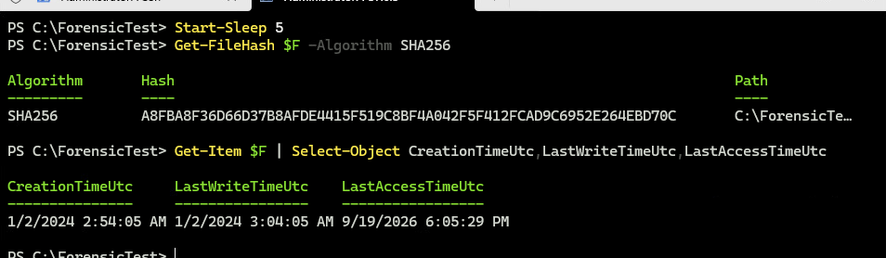
Figure Windows 02. Controlled procedure operation 2; workbook screenshot from September 19
Connection to the container lesson: Slide 2: operations can change metadata without changing content.
Recorded result or expected outcome: Hash matches the baseline. Creation/write remain 2024; displayed access is 2026-09-19 18:05:29 UTC.
Analyst takeaway: A stable content digest can coexist with a later access time.

Windows 03 Normal Copy-Item
Deck slide 27 · Original step Windows 03

Command syntax
Copy-Item $F C:\ForensicTest\CopyItem.txt
Get-Item .\CopyItem.txt | Format-List *TimeUtc
Get-FileHash .\CopyItem.txt -Algorithm SHA256
Why this syntax: Create a new destination and compare its state with Original.txt.
OS and time effect: A newly created destination has its own creation and access history.
Gotcha or ProTip: The 2024 write time does not mean this destination existed in 2024.
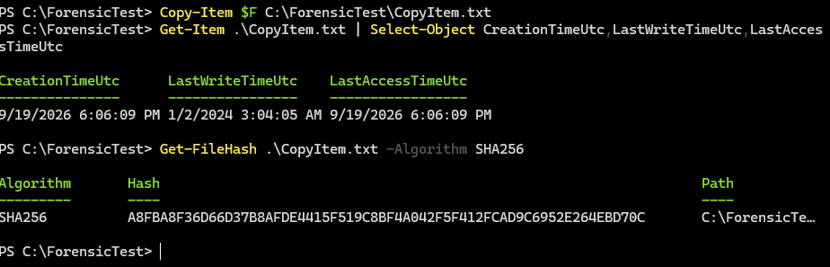
Figure Windows 03. Controlled procedure operation 3; workbook screenshot from September 19
Connection to the container lesson: Slides 2–3: matching bytes do not establish unchanged filesystem identity or every timestamp.
Recorded result or expected outcome: Hash matches. LastWriteTime stays 2024-01-02 03:04:05 UTC; creation/access show 2026-09-19 18:06:09.
Analyst takeaway: Separate inherited timestamps from destination-object history.

Windows 04 Copy-Item -Force
Deck slide 28 · Original step Windows 04

Command syntax
"OLD CONTENT" | Set-Content .\CopyForce.txt
Start-Sleep 5
Copy-Item $F .\CopyForce.txt -Force
Get-Item .\CopyForce.txt | Format-List *TimeUtc,Attributes
Get-FileHash .\CopyForce.txt -Algorithm SHA256
Why this syntax: Overwrite a known existing destination and inspect what changed.
OS and time effect: The captured destination retains its earlier creation time and receives the source write time.
Gotcha or ProTip: -Force allows the operation; it is not a timestamp-preservation switch.
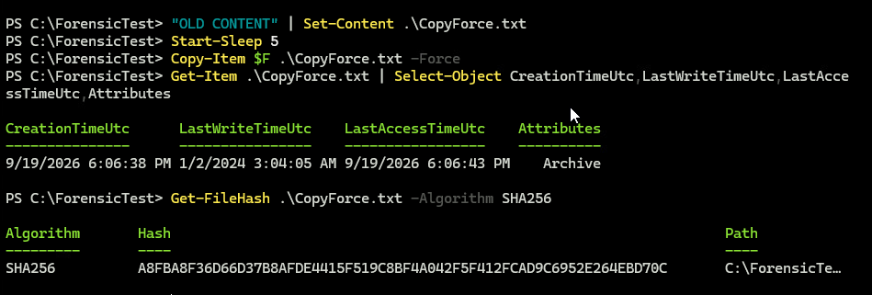
Figure Windows 04. Controlled procedure operation 4; workbook screenshot from September 19
Connection to the container lesson: Slides 2–3: matching bytes do not establish unchanged filesystem identity or every timestamp.
Recorded result or expected outcome: Hash matches. Creation 18:06:38, access 18:06:43 UTC on 2026-09-19; write remains the controlled 2024 value.
Analyst takeaway: Measure overwrite behavior rather than inferring it from the option name.

Windows 05 Robocopy DAT
Deck slide 29 · Original step Windows 05

Command syntax
New-Item -ItemType Directory .\RoboDAT -Force
robocopy C:\ForensicTest C:\ForensicTest\RoboDAT `
Original.txt /COPY:DAT /R:0 /W:0
Get-Item .\RoboDAT\Original.txt | Format-List *TimeUtc
Get-FileHash .\RoboDAT\Original.txt -Algorithm SHA256
Why this syntax: Request file Data, Attributes and Timestamps, with retries disabled for this measured test.
OS and time effect: Robocopy requests selected API-level properties; NTFS still creates destination records.
Gotcha or ProTip: Read the exit code and summary, then verify hashes. DAT does not include all security metadata.
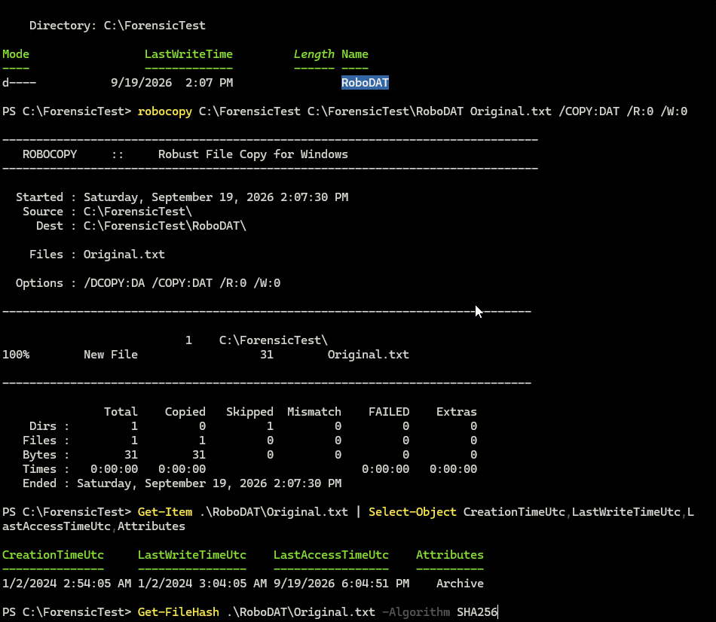
Figure Windows 05. Controlled procedure operation 5; workbook screenshot from September 19
Connection to the container lesson: Slides 2–3: matching bytes do not establish unchanged filesystem identity or every timestamp.
Recorded result or expected outcome: One 31-byte file copied; zero failed. Creation/write show the controlled 2024 values. Hash is shown in the continuation capture.
Analyst takeaway: Requested preservation must be checked at the metadata layer you intend to claim.

Windows 05 Hash verification
Deck slide 30 · Original step Windows 05 result

Command syntax
Get-FileHash .\RoboDAT\Original.txt -Algorithm SHA256
Why this syntax: Complete the DAT operation with a file-content comparison.
OS and time effect: Hashing checks bytes and may cause a read-related metadata update.
Gotcha or ProTip: This digest validates the selected file stream; it does not compare every NTFS attribute.
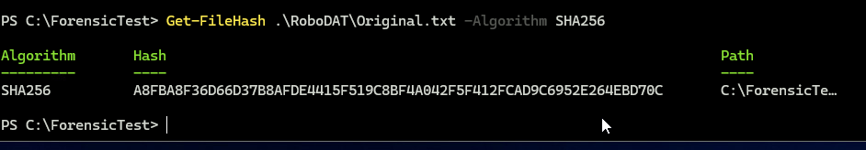
Figure Windows 05 result. Continuation of operation 5, not operation 6
Connection to the container lesson: Slides 2–3: matching bytes do not establish unchanged filesystem identity or every timestamp.
Recorded result or expected outcome: The recorded SHA-256 equals the baseline A8FBA8F3…EBD70C. Retain the full digest in the raw records.
Analyst takeaway: Check content separately from copy success and timestamp display.

Windows 06 Robocopy COPYALL
Deck slide 31 · Original step Windows 06

Command syntax
New-Item -ItemType Directory .\RoboALL -Force
robocopy C:\ForensicTest C:\ForensicTest\RoboALL `
Original.txt /COPYALL /R:0 /W:0
Get-Acl $F | Format-List
Get-Acl .\RoboALL\Original.txt | Format-List
Get-FileHash .\RoboALL\Original.txt -Algorithm SHA256
Why this syntax: Request DATSOU: data, attributes, times, security, owner and auditing information.
OS and time effect: Security metadata requests depend on rights and filesystem support.
Gotcha or ProTip: A successful copy does not prove every audit entry or all FN values were preserved. Inspect the actual fields.
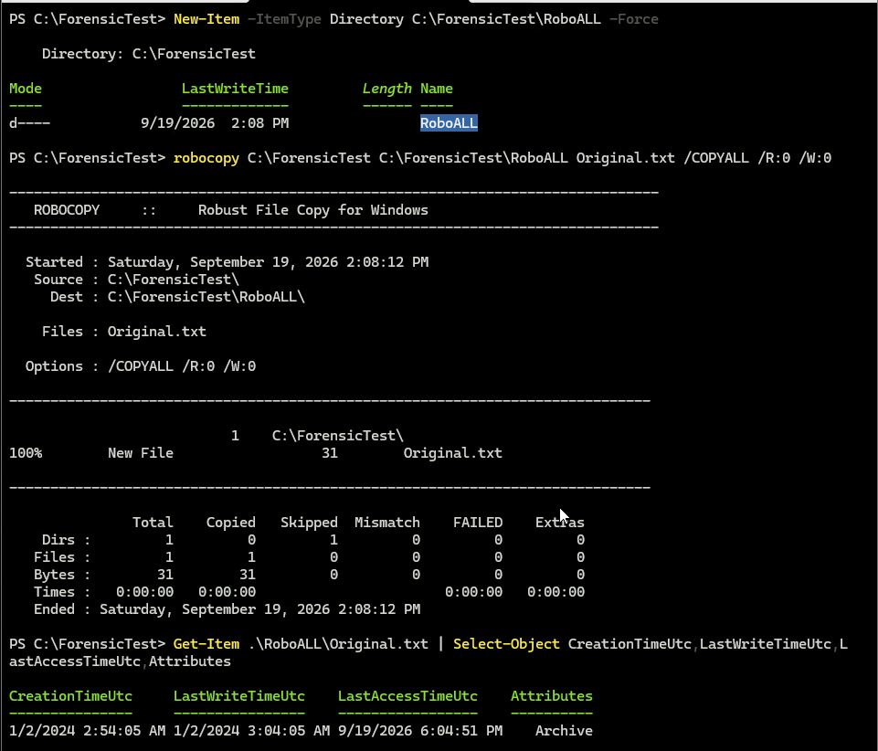
Figure Windows 06. Controlled procedure operation 6; workbook screenshot from September 19
Connection to the container lesson: Slides 2–3: matching bytes do not establish unchanged filesystem identity or every timestamp.
Recorded result or expected outcome: One 31-byte file copied; zero failed. The following ACL capture compares source and destination security.
Analyst takeaway: Compare the requested properties explicitly before widening the preservation claim.

Windows 06 ACL and hash comparison
Deck slide 32 · Original step Windows 06 result

Command syntax
Get-Acl $F | Format-List
Get-Acl .\RoboALL\Original.txt | Format-List
Get-FileHash .\RoboALL\Original.txt -Algorithm SHA256
Why this syntax: Compare the source and COPYALL destination security listings and content.
OS and time effect: The shown owner, group, access entries and SDDL match in this example.
Gotcha or ProTip: The displayed Audit section is blank. Do not claim populated SACL preservation from this result.
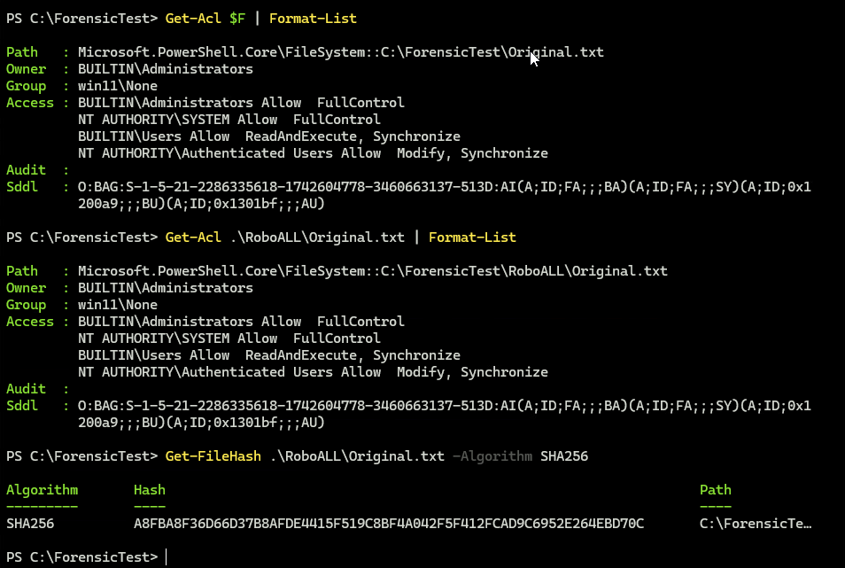
Figure Windows 06 result. Continuation of operation 6, same recorded run
Connection to the container lesson: Slides 2–3: matching bytes do not establish unchanged filesystem identity or every timestamp.
Recorded result or expected outcome: Source/destination owner: BUILTIN\Administrators. Displayed security entries and the content hash match.
Analyst takeaway: State exactly which security fields were compared.

Windows 07 Same-volume rename
Deck slide 33 · Original step Windows 07

Command syntax
Copy-Item $F .\BeforeRename.txt
Get-Item .\BeforeRename.txt | Format-List *TimeUtc
Start-Sleep 5
Rename-Item .\BeforeRename.txt AfterRename.txt
Get-Item .\AfterRename.txt | Format-List *TimeUtc
Get-FileHash .\AfterRename.txt -Algorithm SHA256
Why this syntax: Change a filename on the same volume, then compare content and times.
OS and time effect: The API display remains stable here; the later USN query records the rename operation.
Gotcha or ProTip: API timestamps alone do not establish identity. Correlate entry and sequence numbers with journal context.
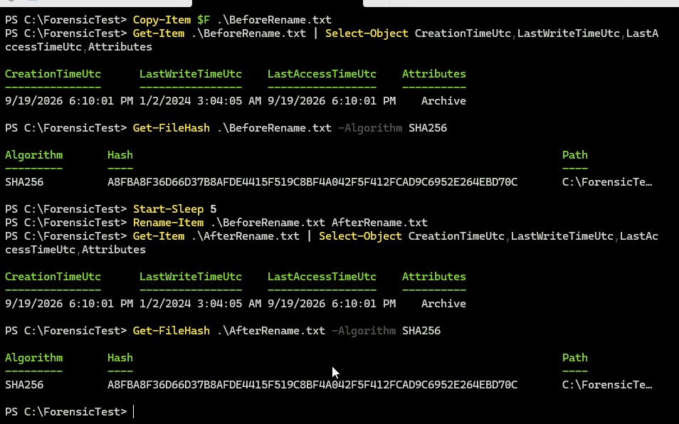
Figure Windows 07. Controlled procedure operation 7; workbook screenshot from September 19
Connection to the container lesson: Slides 2–3: matching bytes do not establish unchanged filesystem identity or every timestamp.
Recorded result or expected outcome: The displayed creation/write/access values and content hash match before and after the rename.
Analyst takeaway: Use journal activity to explain an operation that API timestamps may not reveal.

Windows 08 Content modification
Deck slide 34 · Original step Windows 08

Command syntax
Copy-Item $F .\Modified.txt
Start-Sleep 5
Add-Content .\Modified.txt "CONTENT MODIFIED"
Get-Item .\Modified.txt | Format-List *TimeUtc,Attributes
Get-FileHash .\Modified.txt -Algorithm SHA256
Why this syntax: Append known text so a genuine content change can be compared with metadata-only operations.
OS and time effect: LastWriteTime advances and the content digest changes.
Gotcha or ProTip: Interpret only the specified stream; an ordinary file hash is not a complete disk acquisition.
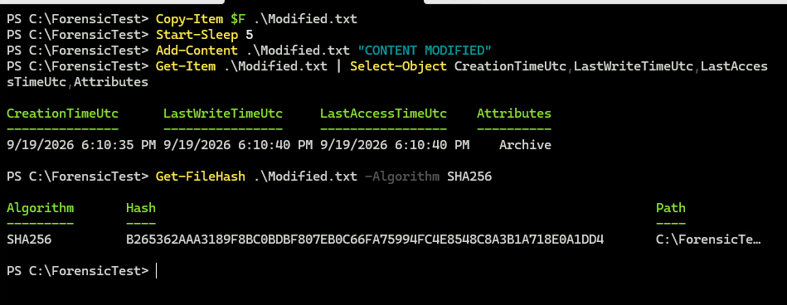
Figure Windows 08. Controlled procedure operation 8; workbook screenshot from September 19
Connection to the container lesson: Slide 2: operations can change metadata without changing content.
Recorded result or expected outcome: Hash begins B265362A, unlike the baseline A8FBA8F3. LastWriteTime is 2026-09-19 18:10:40 UTC.
Analyst takeaway: A changed content digest and write time support the known append operation.

Windows 09 Metadata-only change
Deck slide 35 · Original step Windows 09

Command syntax
Copy-Item $F .\AttributeChange.txt
Start-Sleep 5
attrib +R .\AttributeChange.txt
Get-Item .\AttributeChange.txt | Format-List *TimeUtc,Attributes
Get-FileHash .\AttributeChange.txt -Algorithm SHA256
Why this syntax: Set the read-only attribute without editing the file content.
OS and time effect: The attribute changes; later MFT/USN records provide the metadata-change context.
Gotcha or ProTip: ReadOnly is not forensic write protection. The screenshot alone does not prove which journal reason must appear.
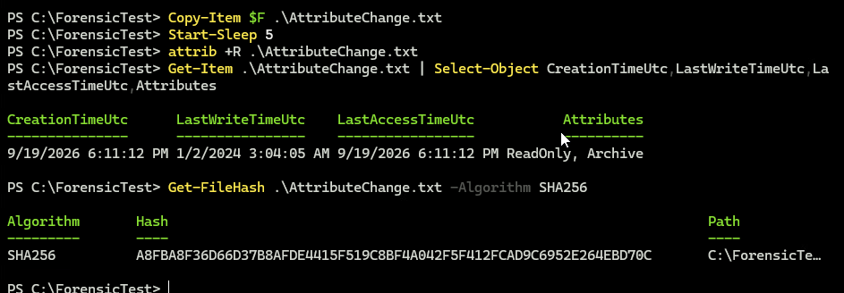
Figure Windows 09. Controlled procedure operation 9; workbook screenshot from September 19
Connection to the container lesson: Slide 2: operations can change metadata without changing content.
Recorded result or expected outcome: Attributes show ReadOnly, Archive. The SHA-256 still matches the baseline.
Analyst takeaway: A metadata change can be real even when the content digest remains equal.

Windows 10 Controlled deletion
Deck slide 36 · Original step Windows 10

Command syntax
Copy-Item $F .\DeleteMe.txt
Start-Sleep 5
Remove-Item .\DeleteMe.txt
Test-Path .\DeleteMe.txt
Why this syntax: Delete only the synthetic test file and examine the remaining records later.
OS and time effect: Path removal changes directory/filesystem state; journal history may persist.
Gotcha or ProTip: Stop experimental operations after this step and preserve the filesystem. False does not prove secure erasure.
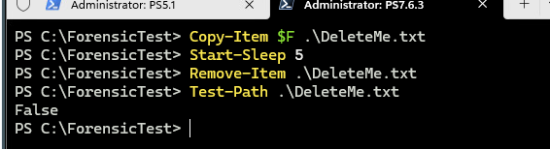
Figure Windows 10. Controlled procedure operation 10; workbook screenshot from September 19
Connection to the container lesson: Slide 2: operations can change metadata without changing content.
Recorded result or expected outcome: Test-Path returns False. The later saved journal includes FileDelete|Close for entry 258305.
Analyst takeaway: Distinguish path absence from absence of historical evidence.

Windows preservation before analysis
Deck slide 37 · Original step Windows acquisition

Command syntax
Original controlled procedure:
Stop after operation 10
Acquire the NTFS volume as E01 or raw image
Retain MFT and $UsnJrnl:$J with context
Hash acquired artifacts and analysis copies
Why this syntax: Preserve the filesystem context required to examine SI/FN timestamps, identities and journal activity.
OS and time effect: Continued use can alter records, allocate new entries or age journal history.
Gotcha or ProTip: The following workbook captures actually used live C: parsing in the disposable VM. That is a documented deviation from the acquisition plan.
Connection to the container lesson: Slides 2–3: Windows API timestamps, NTFS SI/FN attributes and USN journal activity answer different questions.
Recorded result or expected outcome: The visible MFTECmd output says the live file is in use and reroutes access. Do not label that screenshot an offline image parse.
Analyst takeaway: Separate the recommended acquisition plan from what the recorded experiment actually did.

Windows analysis 1 Parse MFT
Deck slide 38 · Original step Windows analysis 1

Command syntax
Set-Location C:\ZimmermanTools\net9
.\MFTECmd.exe -f 'C:\$MFT' `
--csv C:\ForensicAnalysis\ `
--csvf MFT.csv --at
Why this syntax: -f selects the input; --csv selects the output folder; --csvf names the CSV; --at includes all FN timestamps.
OS and time effect: MFTECmd exposes both 0x10 SI and 0x30 FN timestamp fields.
Gotcha or ProTip: The capture parses live C:\$MFT in a disposable VM. For casework, use the acquired artifact path and preserve its provenance.
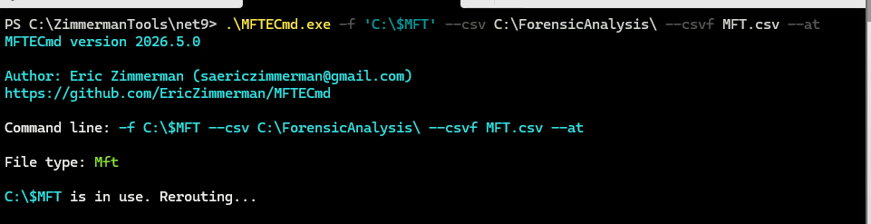
Figure Windows analysis 1. Actual corrected workbook command
Connection to the container lesson: Slides 2–3: Windows API timestamps, NTFS SI/FN attributes and USN journal activity answer different questions.
Recorded result or expected outcome: Actual MFTECmd 2026.5.0 invocation includes --at. It reports C:\$MFT in use and reroutes access.
Analyst takeaway: Use the parsed NTFS fields to explain what the copy actually preserved.

Windows analysis 2 Compare SI and FN
Deck slide 39 · Original step Windows analysis 2

Command syntax
$MFT = Import-Csv C:\ForensicAnalysis\MFT.csv
$MFT | Where-Object {
$_.ParentPath -like '*ForensicTest*'
} | Select-Object FileName,EntryNumber,SequenceNumber,
Created0x10,Created0x30,LastModified0x10,
LastModified0x30 | Format-List
Why this syntax: Filter the acquired/parsed rows to the controlled paths and compare fields by attribute type.
OS and time effect: 0x10 and 0x30 are different NTFS attributes, not duplicate API labels.
Gotcha or ProTip: Use full raw rows and sequence numbers. The shown result is an excerpt, not every property or every record.
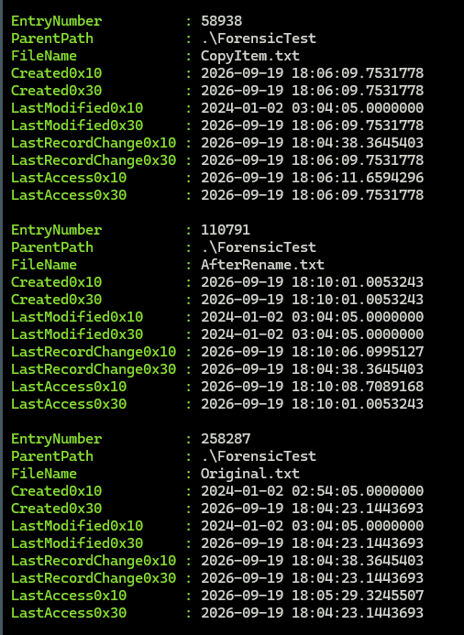
Figure Windows analysis 2. Recorded MFT results; displayed query simplified for the relevant fields
Connection to the container lesson: Slides 2–3: Windows API timestamps, NTFS SI/FN attributes and USN journal activity answer different questions.
Recorded result or expected outcome: Original.txt has a controlled 2024 SI creation value and a 2026 FN creation value. CopyItem.txt has a 2024 SI write value and 2026 FN write value.
Analyst takeaway: A timestamp-preservation claim must name the NTFS attribute being compared.

Windows analysis 3 Parse USN
Deck slide 40 · Original step Windows analysis 3

Command syntax
Set-Location C:\ZimmermanTools\net9
.\MFTECmd.exe `
-f 'C:\$Extend\$UsnJrnl:$J' `
-m 'C:\$MFT' `
--csv C:\ForensicAnalysis\ `
--csvf USN.csv
Why this syntax: -f selects $UsnJrnl:$J; -m supplies the MFT; --csv and --csvf select the journal output.
OS and time effect: The journal records reasons and times for filesystem activity; the MFT supplies name/path context.
Gotcha or ProTip: The captured first row is an unrelated file. Filter the controlled scope before interpreting it as experiment evidence.
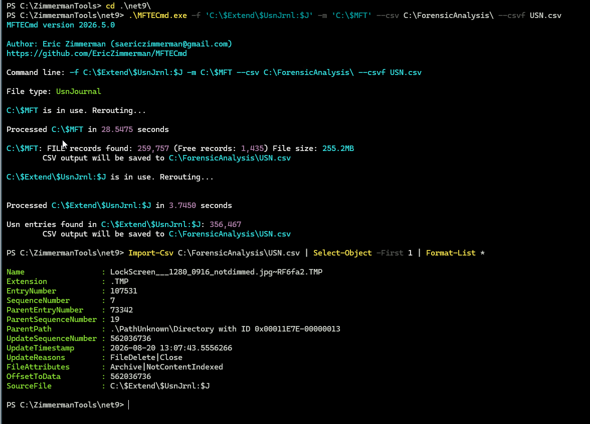
Figure Windows analysis 3. Actual workbook parsing command and CSV schema
Connection to the container lesson: Slides 2–3: Windows API timestamps, NTFS SI/FN attributes and USN journal activity answer different questions.
Recorded result or expected outcome: The tool reports 356,467 journal entries in the live VM. It exposes EntryNumber, SequenceNumber, ParentPath, UpdateTimestamp and UpdateReasons.
Analyst takeaway: Corroborate timestamp interpretations with identified operations and journal records.

Windows analysis 4 Rename correlation
Deck slide 41 · Original step Windows analysis 4

Command syntax
$USN = Import-Csv C:\ForensicAnalysis\USN.csv
$USN | Where-Object {
$_.Name -in 'BeforeRename.txt','AfterRename.txt'
} | Select-Object UpdateTimestamp,Name,EntryNumber,
SequenceNumber,ParentPath,UpdateReasons |
Sort-Object UpdateTimestamp | Format-Table -AutoSize
Why this syntax: The operation renamed a prepared synthetic file. The query selects both names and retains identity and reason fields for comparison.
OS and time effect: USN retains the old/new name reasons and object identifiers for the measured rename.
Gotcha or ProTip: Use sequence numbers from the full export, path and observation window. EntryNumber alone can be reused and is insufficient across arbitrary intervals.
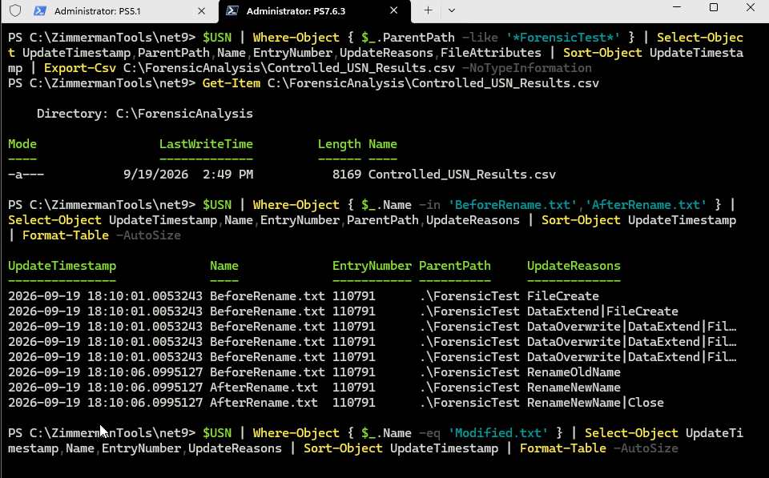
Figure Windows analysis 4. Original rename capture; query includes added sequence field
Connection to the container lesson: Slides 2–3: Windows API timestamps, NTFS SI/FN attributes and USN journal activity answer different questions.
Recorded result or expected outcome: RenameOldName / RenameNewName
Controlled entry 110791
Paired events at 18:10:06.0995127
Analyst takeaway: Known operations plus matching identity context explain a rename more reliably than isolated times.

Windows analysis 5 Content-change history
Deck slide 42 · Original step Windows analysis 5

Command syntax
$USN | Where-Object { $_.Name -eq 'Modified.txt' } |
Select-Object UpdateTimestamp,Name,EntryNumber,
SequenceNumber,UpdateReasons |
Sort-Object UpdateTimestamp | Format-Table -AutoSize
Why this syntax: Correlate the known append in operation 08 with journal entries.
OS and time effect: The saved journal contains DataExtend and DataExtend|Close at the measured append time.
Gotcha or ProTip: A reason code reports an operation category, not the human’s intent. Keep the preceding creation/copy entries too.
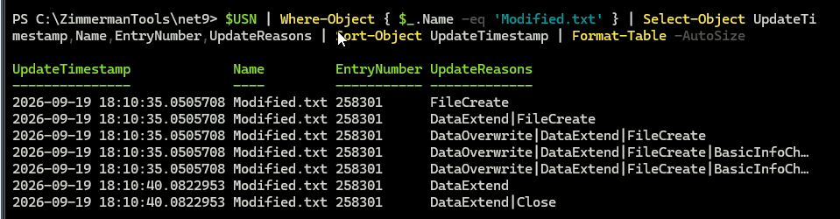
Figure Windows analysis 5. USN focused query for controlled operation 8
Connection to the container lesson: Slides 2–3: Windows API timestamps, NTFS SI/FN attributes and USN journal activity answer different questions.
Recorded result or expected outcome: Modified.txt, entry 258301: DataExtend at 2026-09-19 18:10:40.0822953. Earlier rows belong to creation of the copy.
Analyst takeaway: Use the operation time and surrounding entries to distinguish copy creation from the later edit.

Windows analysis 6 Attribute-change history
Deck slide 43 · Original step Windows analysis 6

Command syntax
$USN | Where-Object { $_.Name -eq 'AttributeChange.txt' } |
Select-Object UpdateTimestamp,Name,EntryNumber,
SequenceNumber,UpdateReasons |
Sort-Object UpdateTimestamp | Format-Table -AutoSize
Why this syntax: The read-only attribute changes. Compare the known command, MFT last-write time, content hash and journal reason.
OS and time effect: USN records BasicInfoChange in the interval of the known attrib operation.
Gotcha or ProTip: BasicInfoChange by itself does not identify the exact field or intent. The controlled command supplies that missing context.
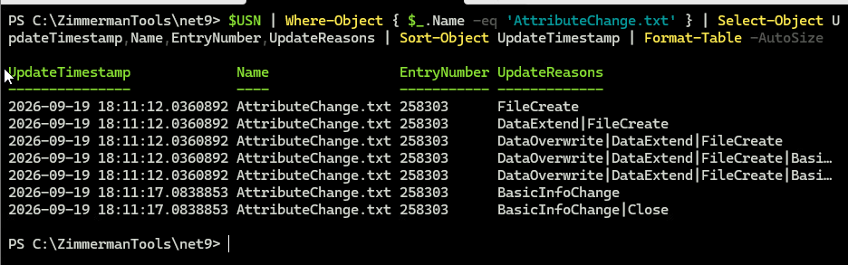
Figure Windows analysis 6. Original attribute-change journal capture
Connection to the container lesson: Slides 2–3: Windows API timestamps, NTFS SI/FN attributes and USN journal activity answer different questions.
Recorded result or expected outcome: Entry 258303: BasicInfoChange
2026-09-19 18:11:17.0838853
$SI last-write remains the 2024 control value.
Analyst takeaway: An unchanged last-write time does not establish that a file was untouched.

Windows analysis 7 Deleted-file history
Deck slide 44 · Original step Windows analysis 7

Command syntax
$USN | Where-Object { $_.Name -eq 'DeleteMe.txt' } |
Select-Object UpdateTimestamp,Name,EntryNumber,
SequenceNumber,ParentPath,UpdateReasons |
Sort-Object UpdateTimestamp | Format-List
Why this syntax: Inspect the saved journal for activity involving the intentionally deleted file.
OS and time effect: A journal entry may remain even though Test-Path is False.
Gotcha or ProTip: No matching screenshot was supplied for this query. The result here comes from the saved CSV, not an invented terminal image.
Connection to the container lesson: Slides 2–3: Windows API timestamps, NTFS SI/FN attributes and USN journal activity answer different questions.
Recorded result or expected outcome: Saved CSV: DeleteMe.txt, entry 258305, includes FileDelete|Close. This establishes a recorded event, not recovered file content.
Analyst takeaway: Preserve and explain historical records independently of current path existence.

C01 Create an isolated practice workspace
Application tutorial C01 · Supports slides 2–4; no separate deck slide

Command syntax
set -euo pipefail
for cmd in stat sha256sum tar getfacl \
getfattr findmnt mktemp; do
command -v "$cmd" >/dev/null || exit 1
done
lab=$(mktemp -d "$HOME/ContainerLab.XXXXXXXX")
mkdir "$lab/source" "$lab/records" \
"$lab/received"
printf 'Synthetic forensic container lab\n' \
> "$lab/source/evidence.log"
cd "$lab/source"
Why this syntax: mktemp creates a new run folder. The synthetic evidence.log is the only evidence fixture in this exercise. Stop at an error.
OS and time effect: Creates new directories and a synthetic file with new filesystem timestamps. It does not touch original evidence.
Gotcha or ProTip: Do not replace the fixture with original evidence. Provision missing tools before the lab; do not bypass permissions by switching to root.
Connection to the container lesson: Foundation claims F3–F4: container scope and transition verification
Recorded result or expected outcome: Capture your result:
printf '%s\n' "$lab"
ls -l "$lab/source"
Expected fixture: evidence.log
Analyst takeaway: A new run folder prevents an earlier result from being mistaken for current evidence.

C02 Record the source environment
Application tutorial C02 · Supports slides 2–4; no separate deck slide

Command syntax
{
date -u --iso-8601=ns
cat /etc/os-release
uname -a
findmnt -T . \
-o TARGET,SOURCE,FSTYPE,OPTIONS
stat --version
tar --version
} > environment.txt
cat environment.txt
Why this syntax: Record the clock context, OS, tool versions, filesystem and mount policy before interpreting timestamps.
OS and time effect: These queries record clock, filesystem, mount policy and tool versions needed to interpret later timestamps.
Gotcha or ProTip: The reference run used ext4 with relatime. Your filesystem and time policy may produce different results.
Connection to the container lesson: Foundation claims F3–F4: container scope and transition verification
Recorded result or expected outcome: Local qualification: Ubuntu 26.04.1 under WSL1, wslfs mounted noatime. Your classroom environment must be recorded separately.
Analyst takeaway: Timestamp findings belong to the recorded environment and operation.

C03 Capture metadata BEFORE hashing
Application tutorial C03 · Supports slides 2–4; no separate deck slide

Command syntax
# Remain in "$lab/source"
stat evidence.log > source-state.txt
getfacl -p evidence.log > evidence.acl
getfattr -d -m- evidence.log \
> evidence.xattrs
cat source-state.txt
cat evidence.acl
cat evidence.xattrs
Why this syntax: stat records identity, size and times. getfacl records ACLs; getfattr records extended attributes independently of the content digest.
OS and time effect: stat reads recorded metadata; getfacl and getfattr record separate metadata classes before the content hash read.
Gotcha or ProTip: An empty xattr listing can be valid; an error is not. Keep offsets and fractional seconds. Metadata capture is not a write blocker.
Connection to the container lesson: Foundation claims F3–F4: container scope and transition verification
Recorded result or expected outcome: Local qualification: basic ACL recorded; xattr listing empty. Populated ACL/xattr preservation was not established.
Analyst takeaway: Capture source state before a content read can change access time.

C04 Hash content and record the post-read state
Application tutorial C04 · Supports slides 2–4; no separate deck slide

Command syntax
sha256sum evidence.log > evidence.sha256
stat evidence.log > after-hash-state.txt
cat evidence.sha256
rc=0
diff -u source-state.txt \
after-hash-state.txt || rc=$?
# diff: 0 = equal, 1 = differences
# Greater than 1 = comparison error
if (( rc > 1 )); then exit "$rc"; fi
Why this syntax: The checksum uses a relative filename so it can be checked after extraction. Compare the metadata before and after hashing.
OS and time effect: SHA-256 reads the content. The filesystem and mount policy decide whether that read changes atime.
Gotcha or ProTip: Compare source-state.txt with after-hash-state.txt. An unchanged atime here does not prove that reads never change it.
Connection to the container lesson: Foundation claims F3–F4: container scope and transition verification
Recorded result or expected outcome: Local qualification: the synthetic content check passed. Retained stat records document this run’s state.
Analyst takeaway: A matching content hash and a metadata change can both be valid observations.

C05 Define exactly what enters the container
Application tutorial C05 · Supports slides 2–4; no separate deck slide

Command syntax
ls -l -- \
evidence.log \
evidence.sha256 \
source-state.txt \
after-hash-state.txt \
environment.txt \
evidence.acl \
evidence.xattrs
Why this syntax: One evidence file and six supporting records enter this small container. The archive and its own hash will live outside source/.
OS and time effect: The explicit list fixes collection scope. An omitted file cannot be recovered by validating the archive hash.
Gotcha or ProTip: Hash equality cannot reveal a file omitted before packaging. Record selection scope and reasons for exclusions in your custody record.
Connection to the container lesson: Foundation claims F3–F4: container scope and transition verification
Recorded result or expected outcome: Seven explicit members
No wildcard expansion
No archive inside its own source set
Capture the inventory before packaging.
Analyst takeaway: Define the collection scope before declaring a container complete.

C06 Create the forensic file container
Application tutorial C06 · Supports slides 2–4; no separate deck slide

Command syntax
# Working directory: "$lab/source"
tar --format=pax --acls --xattrs \
--numeric-owner --atime-preserve=system \
-czf "$lab/evidence.tar.gz" \
evidence.log evidence.sha256 \
source-state.txt after-hash-state.txt \
environment.txt evidence.acl evidence.xattrs
Why this syntax: -c creates, -z gzip-compresses, -f names the archive. pax supports extended metadata. --acls/--xattrs request supported metadata.
OS and time effect: TAR creates a new archive and reads its members. --atime-preserve=system requests protection against source atime changes.
Gotcha or ProTip: --atime-preserve=system attempts to avoid TAR read effects. It does not undo earlier reads or preserve original ctime/birth on extraction.
Connection to the container lesson: Foundation claims F3–F4: container scope and transition verification
Recorded result or expected outcome: Local qualification: TAR creation completed with the seven explicit members.
Analyst takeaway: Package selected content and metadata, then verify what the archive actually contains.

C07 List the archive before transfer
Application tutorial C07 · Supports slides 2–4; no separate deck slide

Command syntax
cd "$lab"
tar -tzf evidence.tar.gz \
> records/archive-members.txt
cat records/archive-members.txt
Why this syntax: -t lists members, -z reads gzip compression, -f selects the archive. Compare every listed name with the seven-file scope.
OS and time effect: Listing reads the archive directory without extracting its members. Compare the names against the intended scope.
Gotcha or ProTip: Stop on missing or unexpected members and unresolved errors. A correct member list does not prove that the original collection scope was sufficient.
Connection to the container lesson: Foundation claims F3–F4: container scope and transition verification
Recorded result or expected outcome: Expected names, not a recorded screenshot:
evidence.log · evidence.sha256
source-state.txt · after-hash-state.txt
environment.txt · evidence.acl · evidence.xattrs
Analyst takeaway: Verify archive membership as well as its digest.

C08 Hash the finished container
Application tutorial C08 · Supports slides 2–4; no separate deck slide

Command syntax
sha256sum evidence.tar.gz \
> evidence.tar.gz.sha256
cat evidence.tar.gz.sha256
date -u --iso-8601=ns
# Retain an independent receipt BEFORE transfer:
# case/run ID, filename, complete SHA-256,
# sender, recipient, UTC time, scope and method
Why this syntax: Hash the completed archive. Give the full digest and identifying details to the instructor through the designated receipt process.
OS and time effect: Hashing reads the finished archive bytes. Its digest covers the container, not just evidence.log.
Gotcha or ProTip: A sidecar stored beside an editable archive is not independent authentication. The archive digest and each member digest answer different questions.
Connection to the container lesson: Foundation claims F3–F4: container scope and transition verification
Recorded result or expected outcome: Local archive SHA-256 begins 50658bf7; the full digest is retained in the qualification receipt. Use your own new digest.
Analyst takeaway: Keep an independently trusted expected digest before the file leaves the source.

C09 Transfer the archive to Windows
Application tutorial C09 · Supports slides 2–4; no separate deck slide

Command syntax
# Obtain the real account, host and destination.
# This example contains placeholders.
scp -p \
"$lab/evidence.tar.gz" \
"$lab/evidence.tar.gz.sha256" \
analyst@lab.example:/cases/lab409/
Why this syntax: The instructor must provide a reachable, verified SSH/SFTP endpoint and a valid destination path. -p requests outer-file times and mode bits.
OS and time effect: The receiver creates a new filesystem object. scp -p requests access/modification times and mode bits; it does not preserve every metadata class.
Gotcha or ProTip: The Windows server’s path syntax and permissions must be tested. Stop for an unverified host key. No supplied capture demonstrates this endpoint transfer.
Connection to the container lesson: Foundation claims F3–F4: container scope and transition verification
Recorded result or expected outcome: Evidence still needed for this step:
Exact endpoint command and exit status
Sender/receiver paths and UTC times
Receiver hash matched to trusted receipt
Analyst takeaway: Transfer the intact archive and independently verify its bytes at the receiver.

C10 Verify receipt on Windows
Application tutorial C10 · Supports slides 2–4; no separate deck slide

Command syntax
$archive = Read-Host 'Received archive path'
$expected = (Read-Host 'Trusted SHA256').Trim()
if ($expected -notmatch '^[0-9A-Fa-f]{64}$') {
throw 'Expected 64 hexadecimal characters'
}
$actual = (Get-FileHash -LiteralPath $archive `
-Algorithm SHA256).Hash
if ($actual -ine $expected) {
throw 'Container hash mismatch'
}
'Container bytes match the supplied receipt'
Why this syntax: Paste the independently recorded sender digest. The comparison stops on a malformed receipt or a mismatch.
OS and time effect: Get-FileHash reads the received archive. A match verifies its bytes against the independently supplied expected digest.
Gotcha or ProTip: A successful hash check covers the received archive bytes. It does not establish the sender’s identity, original scope or metadata restoration.
Connection to the container lesson: Foundation claims F3–F4: container scope and transition verification
Recorded result or expected outcome: Actual local receipt-code checks:
Matching digest: accepted
Changed digest: rejected
Malformed digest: rejected
These checks did not test an SSH transfer.
Analyst takeaway: Verify before extraction, and preserve the received archive intact.

C11 Rehearse receipt verification on Linux
Application tutorial C11 · Supports slides 2–4; no separate deck slide

Command syntax
cp -- "$lab/evidence.tar.gz" "$lab/received/"
cp -- "$lab/evidence.tar.gz.sha256" \
"$lab/received/"
cd "$lab/received"
sha256sum -c evidence.tar.gz.sha256
sha256sum evidence.tar.gz
Why this syntax: The first check uses the sidecar’s relative filename. Compare the second printed digest to the independent instructor receipt too.
OS and time effect: The local copy creates a receipt rehearsal on Ubuntu. It does not test network transport or a Windows filesystem.
Gotcha or ProTip: This local rehearsal is not the Windows network transfer. After a real return transfer to Ubuntu, verify again before analysis.
Connection to the container lesson: Foundation claims F3–F4: container scope and transition verification
Recorded result or expected outcome: Expected success text:
evidence.tar.gz: OK
Capture the actual output and full digest.
A missing file or mismatch is a stop condition.
Analyst takeaway: Each transfer has its own recorded verification boundary.

C12 Extract into a new Linux directory
Application tutorial C12 · Supports slides 2–4; no separate deck slide

Command syntax
cd "$lab/received"
tar -tzf evidence.tar.gz
mkdir extracted
tar --acls --xattrs --no-same-owner \
-xzf evidence.tar.gz -C extracted
cd extracted
Why this syntax: -x extracts; -C chooses the new destination. --no-same-owner makes the ordinary-user exercise explicit. Preserve the received archive.
OS and time effect: Extraction creates new destination objects. Stored mtime may survive while inode, ctime and birth time describe extraction.
Gotcha or ProTip: Existing extracted/ causes mkdir to fail. Do not overwrite an earlier result. GNU tar’s default xattr extraction scope is the user namespace.
Connection to the container lesson: Foundation claims F3–F4: container scope and transition verification
Recorded result or expected outcome: Local qualification: extraction completed into a new directory. All seven members matched their source bytes.
Analyst takeaway: Extraction creates destination objects, even when member content remains identical.

C13 Verify extracted content before analysis
Application tutorial C13 · Supports slides 2–4; no separate deck slide

Command syntax
stat evidence.log \
> "$lab/records/destination-before-hash.txt"
sha256sum -c evidence.sha256
stat evidence.log \
> "$lab/records/destination-after-hash.txt"
cat "$lab/records/destination-before-hash.txt"
Why this syntax: The stored relative checksum now names the extracted evidence.log. Capture metadata before and after the verification read.
OS and time effect: The extracted-file hash reads evidence.log. Capture metadata before and after to distinguish extraction from read effects.
Gotcha or ProTip: Capture this run’s full digest, output and any errors. An earlier PASS is not evidence for the current extraction.
Connection to the container lesson: Foundation claims F3–F4: container scope and transition verification
Recorded result or expected outcome: Local qualification: extracted evidence.log matched its stored SHA-256.
Analyst takeaway: Verify both the container bytes and the extracted evidence bytes.

C14 Compare timestamps and identity
Application tutorial C14 · Supports slides 2–4; no separate deck slide

Command syntax
cat source-state.txt
cat "$lab/records/destination-before-hash.txt"
rc=0
diff -u source-state.txt \
"$lab/records/destination-before-hash.txt" \
|| rc=$?
if (( rc > 1 )); then exit "$rc"; fi
Why this syntax: Compare Access, Modify, Change, Birth, inode/device, size, mode and ownership. Record the offset and full available precision.
OS and time effect: Comparison is observational: differences in identity and creation/change fields can be expected for new destination objects.
Gotcha or ProTip: diff exit 1 means differences, not a failed command. Expected differences still need explanation. ctime is not creation time or a tamper-proof clock.
Connection to the container lesson: Foundation claims F3–F4: container scope and transition verification
Recorded result or expected outcome: Compare the retained source and destination stat records. Do not import inode/time values from the earlier ext4 screenshot run.
Analyst takeaway: Report which fields survived and which describe the new destination object.

C15 Compare ACLs and extended attributes
Application tutorial C15 · Supports slides 2–4; no separate deck slide

Command syntax
getfacl -p evidence.log \
> "$lab/records/destination.acl"
getfattr -d -m- evidence.log \
> "$lab/records/destination.xattrs"
rc=0
diff -u evidence.acl \
"$lab/records/destination.acl" || rc=$?
if (( rc > 1 )); then exit "$rc"; fi
rc=0
diff -u evidence.xattrs \
"$lab/records/destination.xattrs" || rc=$?
if (( rc > 1 )); then exit "$rc"; fi
Why this syntax: Compare the stored source listings with fresh destination listings. Explain unsupported fields and ownership differences.
OS and time effect: ACLs and xattrs are separate from the content digest. Matching empty xattr listings cannot validate populated xattr preservation.
Gotcha or ProTip: An empty matching xattr pair tests no populated attributes. Qualify broader preservation claims with populated test metadata.
Connection to the container lesson: Foundation claims F3–F4: container scope and transition verification
Recorded result or expected outcome: Local qualification: basic ACL listings matched; both xattr listings were empty. Stronger metadata coverage remains open.
Analyst takeaway: A file-content digest does not replace an ACL or extended-attribute comparison.

C16 Record a bounded preservation conclusion
Application tutorial C16 · Supports slides 2–4; no separate deck slide

Command syntax
Container digest matched trusted receipt: ____
Seven named members accounted for: ____
Extracted evidence hash matched: ____
Metadata compared and differences explained: ____
Unverified steps and limitations recorded: ____
Why this syntax: State: “I verified these archive bytes against receipt [ID]. The extracted file matched its stored digest. Fields [X] matched; [Y] changed because [supported reason].”
OS and time effect: The conclusion separates content equality, preserved metadata and newly created destination state; each needs its own supporting record.
Gotcha or ProTip: Do not claim a whole filesystem, every timestamp, or an untested endpoint was preserved. Retain failed checks and explain their resolution.
Connection to the container lesson: Foundation claims F3–F4: container scope and transition verification
Recorded result or expected outcome: Review gates:
All intended members present
Both digest comparisons pass
Metadata differences explained
Custody and exceptions documented
Analyst takeaway: Make each preservation claim traceable to commands, records and verified results.

Student submission and primary references
For each command ID, record your actual command, UTC time, tool/OS versions, filesystem and policy, before/after fields, full hashes, screenshot and raw-log filenames, and any warning or skipped step. Explain why the observed result supports the stated conclusion and what it cannot establish. Keep the source, container, receipt and extracted working copy distinguishable.
Guttman, B., White, D. R., & Walraven, T. (2022). Digital evidence preservation: Considerations for evidence handlers (NIST IR 8387). https://doi.org/10.6028/NIST.IR.8387
Free Software Foundation. (n.d.). GNU tar manual. https://www.gnu.org/software/tar/manual/tar.html
Free Software Foundation. (n.d.). GNU Coreutils manual. https://www.gnu.org/software/coreutils/manual/coreutils.html
Linux man-pages project. (n.d.). inode(7). https://man7.org/linux/man-pages/man7/inode.7.html
Microsoft. (n.d.). File times. https://learn.microsoft.com/en-us/windows/win32/sysinfo/file-times
Microsoft. (n.d.). Robocopy. https://learn.microsoft.com/en-us/windows-server/administration/windows-commands/robocopy
OpenBSD Project. (n.d.). scp(1). https://man.openbsd.org/scp.1
Zimmerman, E. (n.d.). MFTECmd. https://github.com/EricZimmerman/MFTECmd
Local sources: the two validation workbooks; Linux_Forensic_Time_Validator.sh; the controlled Windows procedure and automated harness; saved MFT/USN CSVs; and QA/Native_Container_20260920. Original captures remain unchanged in Source. The source map identifies each image and command ID.
Preservation principle: Preserve what you can; document what you cannot preserve; verify every transition.
Email qualification: the comparison concerns unverified loose-file attachments. MIME can carry optional date parameters, but actual sender/receiver support must be checked. A verified intact archive can use an authorized transport with handling records. See https://www.rfc-editor.org/rfc/rfc2183.html.

